Experiment 5

Student Name: Ghanshyam kr UID:22BCS12738

Branch: BE-CSE Section/Group:637/B

Semester:6 Date of Performance:14-2-25

Subject Name: AP LAB Subject Code:22CSH-359

1. Problem statement- Given the roots of two binary trees p

and q, write a function to check if they are the same or not.Two

binary trees are considered the same if they are structurally

identical, and the nodes have the same value.

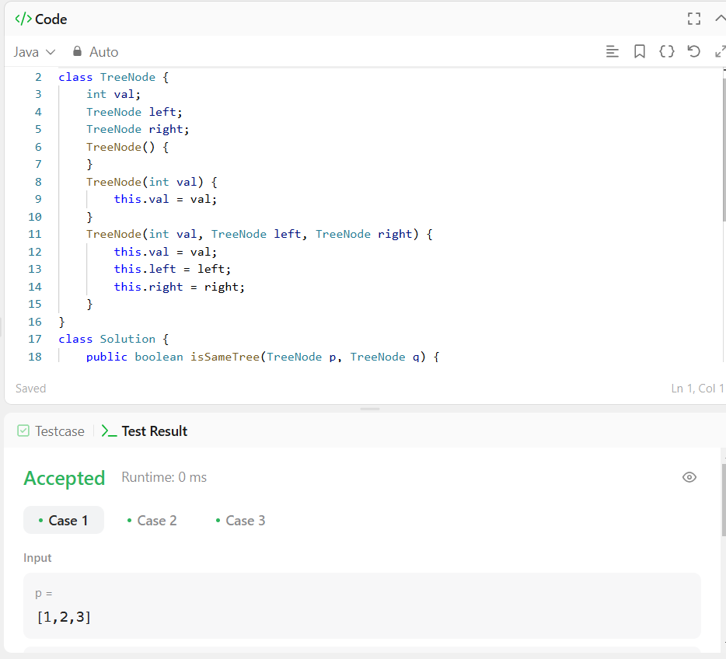

2. Problem statement- Given the root of a binary tree, check whether it is a mirror of itself (i.e., symmetric around its center)

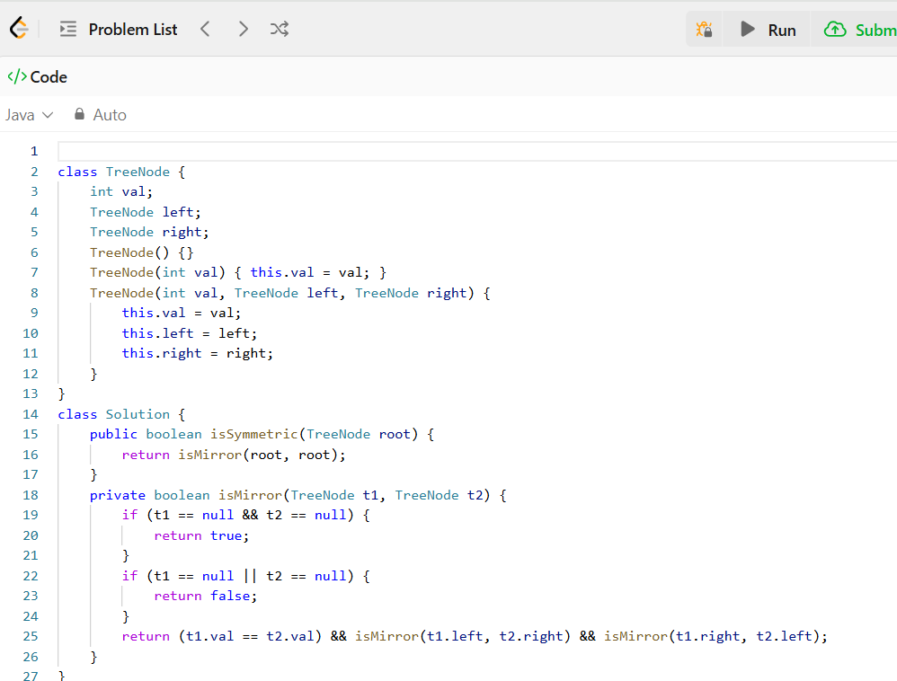

3. Problem statement- Given a binary tree, determine if it is height-balanced.

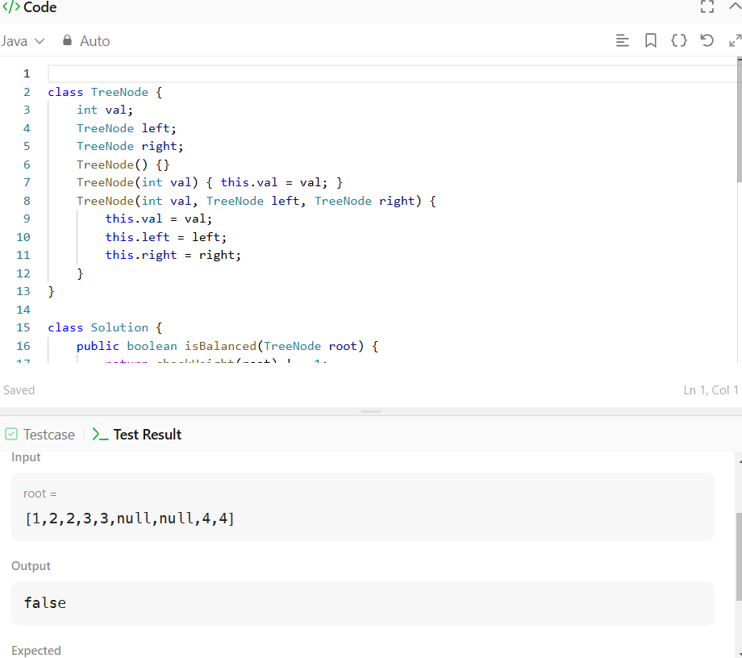

4. Problem statement- Given the root of a binary tree and an integer targetSum, return true if the tree has a root-to-leaf path such that adding up all the values along the path equals targetSum.

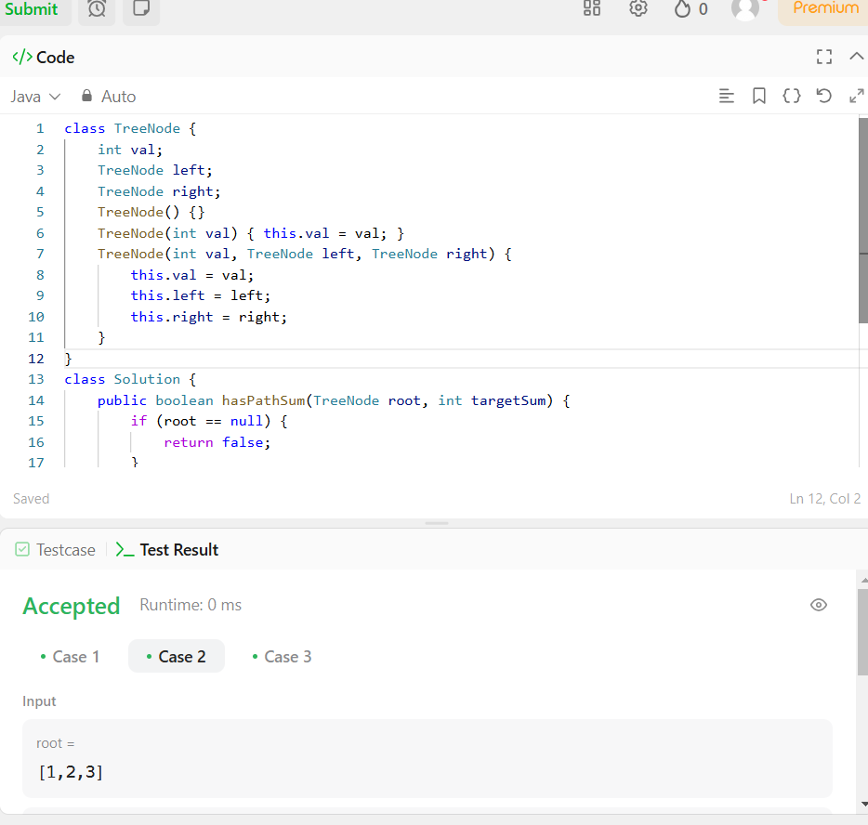

5. Problem statement- Given the root of a complete binary tree, return the number of the nodes in the tree. According to Wikipedia, every level, except possibly the last, is completely filled in a complete binary tree, and all nodes in the last level are as far left as possible. It can have between 1 and 2h nodes CO3 inclusive at the last level h. Design an algorithm that runs in less than O(n) time complexity

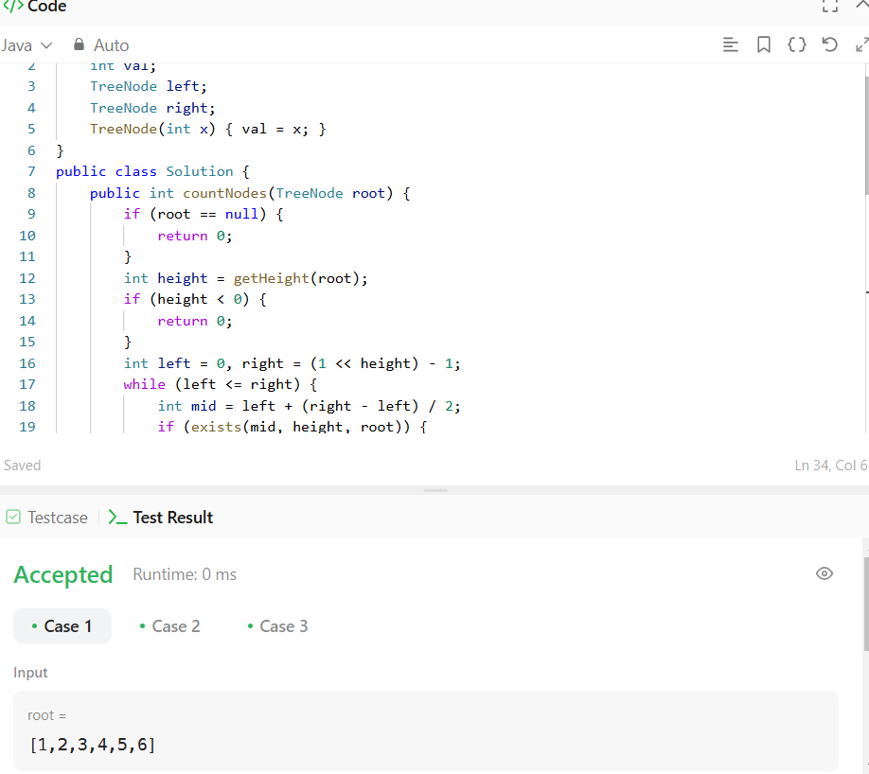

6. Problem statement- Given a root node reference of a BST and a key, delete the node with the given key in the BST. Return the root node reference (possibly updated) of the BST. Basically, the deletion can be divided into two stages: Search for a node to remove. If the node is found, delete the node.

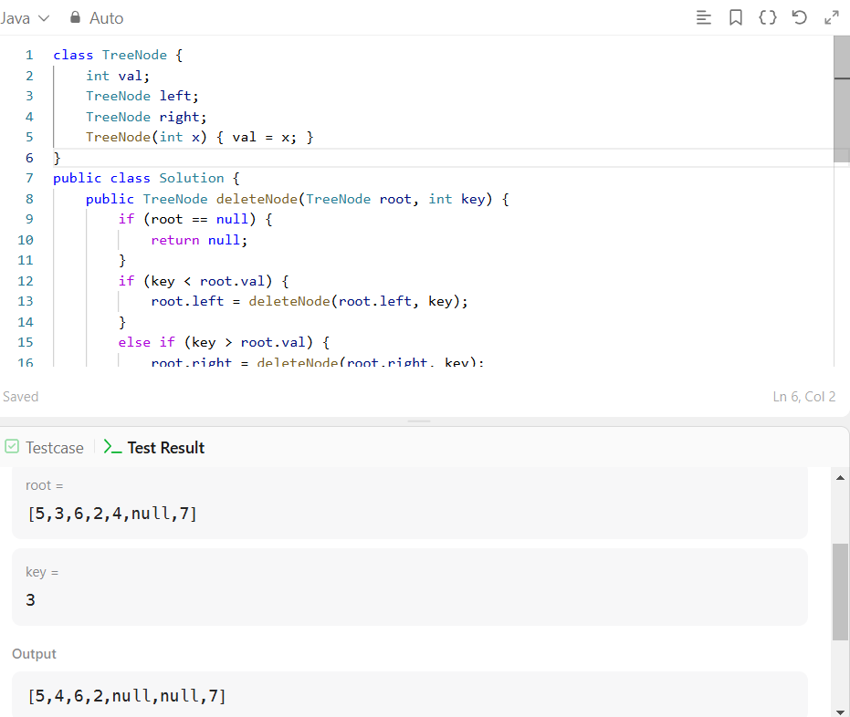

7. Problem statement- Given the root of a binary tree, return the length of the diameter of the tree. The diameter of a binary tree is the length of the longest path between any two nodes in a tree. This path may or may not pass through the root. The length of a path between two nodes is represented by the number of edges between them.

